Clan Henderson Society

Scholarship Fund Raising Program
Annual Report 2022

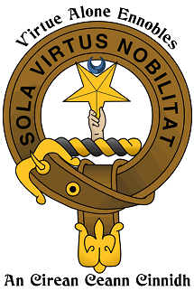

www.clanhendersonsociety.org
Executive Summary
Establishment of a Scholarship Fund was part of the vision for founding the Clan Henderson Society. Supporting education of the next generation is an important way to insure continuation of Scottish Culture. The Society is proud of its accomplishments.
This is the fourth year of the CHS Corporate Sponsor Program. Historically, scholarship funding had come from the operating budget and from member donations. This continues. This year a significant effort was made to increase individual member donations and to generate additional Scholarship Funds through the first CHS Christmas Card program.

Clan Henderson Society 2022 Scholarship Fund & Contributions
Hiking for Henderson’s | Not reported at this time
Corporate sponsors | $1000
CHS Christmas Card | $ 670
Individual donations | $7500
Total | $8670

Clan Henderson Society Scholarship Program Corporate Sponsors 2021.

